SEG Awards Level 2

Motor Vehicle Studies

Underpinning Knowledge Evidence Record

T/601/5558 Knowledge of Removing and Replacing Motorcycle Chassis Units and Components

Learners Name
SEG Awards Registration Number
Centre Name
Assessor 1 Name
Assessor 2 Name

DECLARATION OF AUTHENTICITY

This declaration must be completed and signed by the learner and countersigned by the tutor / assessor and covers all evidence submitted for moderation.

Learner Name
Unique Learner Number (ULN) |  | SEG  Learner Reg. ID
Qualification Title
Centre Name

Learner statement of authenticity

Before signing please read the guidance below.

I confirm, that the attached assignment / portfolio is all my own work and does not include any work completed by anyone other than myself. I have completed the assignment / portfolio in accordance with SEG Awards’ instructions and within the time limits set by my centre.

Signature |  | Date

Centre confirmation of authenticity

On behalf of …………………………………….(insert centre name), I confirm that the above mentioned learner, to the best of my knowledge, is the sole author of the completed assignment / portfolio attached, and the assessments have been completed under the required conditions.

Signed |  | Date
Name
Title

Guidance for Learners

You have been asked to sign this Declaration of Authenticity and place it at the front of your portfolio or course work assessment. It confirms that the work you have submitted for assessment is your own and that you have not copied it from someone else or allowed another learner to copy it from you.

When preparing any course work it is good practice to undertake research using information from published sources. If you quote directly from these sources then this must be indicated in your work by using quotation marks and referencing the document from which the quotation was taken. You must then comment in your own words on any ideas expressed.

Assessors, internal verifiers and SEG Awards’ external moderators and verifiers are subject specialists who can spot the use of published materials that may be passed as your own words or ideas.
If you do copy words from a published source and do not indicate their reference you will be committing plagiarism. This is considered a form of cheating and may result in your assessment being declared void.

Contents

Task No | Title | Assessment Criteria
1 | Motorcycle suspension and steering systems | 1.1, 1.2, 1.3, 1.4, 1.5
2 | Brake layout and operation | 2.1, 2.2, 2.3, 2.4, 2.5
3 | Motorcycle wheels and tyres | 3.1, 3.2, 3.4, 3.5
4 | Check and replace systems | 4.1, 4.2, 4.3, 4.4

Task 1 – Motorcycle suspension and steering systems | Assessment Criteria 1.1, 1.2, 1.3, 1.4, 1.5

On the frame below draw and label suspension system components
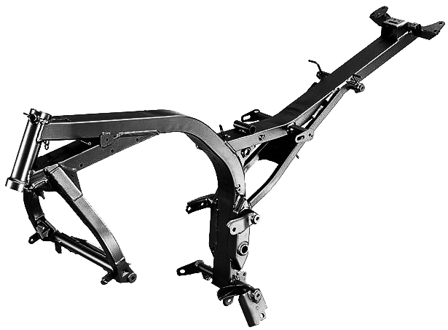
Describe and compare the construction and operation of motorcycle suspension and steering systems
Component | Construction and operation

Explain the following key engineering principles relating to suspension
Principle | Explanation
Steering angle
Hydraulic forces
Stress and strain

Task 2 – Brake layout and operation | Assessment Criteria 2.1, 2.2, 2.3, 2.4, 2.5

Draw a diagram of a typical motorcycle braking system layout | Label Diagram | Explain their operation
 | 1
 | 2
 | 3
 | 4
 | 5
 | 6
 | 7

Draw a diagram of a motorcycle disc brake | Label Diagram | Explain their operation
 | 1
 | 2
 | 3
 | 4
 | 5
 | 6
 | 7

Draw a diagram of a motorcycle drum brake | Label Diagram | Explain their operation
 | 1
 | 2
 | 3
 | 4
 | 5
 | 6
 | 7

Compare the different systems explaining advantages and disadvantages
Component | Comparison
Hydraulic /mechanical
Disc/drum

Describe the following key engineering principles relating to brakes
Principle | Explanation
Laws of friction
Hydraulics
Properties of fluids
Properties of air
Braking efficiency

Task 3 – Motorcycle wheels and tyres | Assessment Criteria 3.1, 3.2, 3.4, 3.5

In the table below identify the labelled components on the following tyre diagram, giving a description of each component
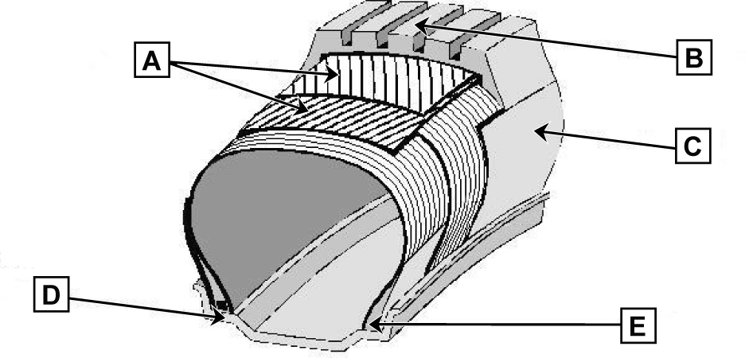
 | Tyre Component | Description
A
B
C
D
E

Draw and label a diagram of a motorcycle spoked wheel | Label Diagram | Explain their operation
 | 1
 | 2
 | 3
 | 4
 | 5

Draw and label a diagram of a motorcycle alloy wheel | Label Diagram | Explain their operation
 | 1
 | 2
 | 3
 | 4
 | 5

Compare different wheel and tyre components explaining the advantages and disadvantages of each
Component | Comparison
Tyres
Wheels

Describe the following key engineering principles relating to wheels and tyres
Principle | Explanation
Un-sprung weight
Dynamic balance
Static balance

Task 4 – Check and replace systems | Assessment Criteria 4.1, 4.2, 4.3, 4.4

Describe how to remove, test, evaluate and replace the following system/components
Steering system/components
Suspension system/components
Brake system/components
Wheels and tyres

Give at least 3 examples of common chassis system faults and describe the common causes for each
 | Fault 1 | Fault 2 | Fault 3
Frame
Steering
Suspension
Brakes

Unless otherwise stated e.g. for some entry level qualifications, learners can work together but should identify sections which are their own work.

